Week Ending: | DAY: |  |  | Subject: Creative Arts
Duration: 60mins per lesson |  |  |  | Strand: Visual Arts & Performing Arts
Class: B5 | Class Size: |  |  | Sub Strand: Appreciating and Appraising
Content Standard:  Demonstrate understanding of how to generate own ideas for artistic expressions on the people. |  |  | Indicator:  B5.1.4.6 /B5.2.4.7 use the agreed guidelines to examine and derive meaning from own artworks |  |  | Lesson:  1 OF 1
Performance Indicator:  Learners can use the agreed guidelines to examine and derive meaning from own artworks. |  |  |  |  | Core Competencies:  Decision Making Creativity, Innovation Communication
Teaching/ Learning Resources |  | Photos, videos, art paper, colors and traditional art tools
References: Creative Arts Curriculum Pg. 65
DAYS | PHASE 1: STARTER | PHASE 2: MAIN | PHASE 3: REFLECTION
 | Engage learners to play games and sing songs to begin the lesson.  Review learners understanding in the previous lesson using questions and answers | Let learners use their senses to appreciate and appraise their own artworks.  Make decisions on agreed guidelines to appreciate and appraise an artwork.  E.g. a painting  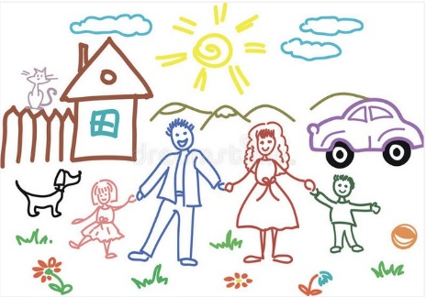  Have learners to talk about the painting.  i. what’s going on in the painting  ii. what do you see that makes you say that?  iii. what more can we find? | Assessment: Present learners with different artworks for them to use the guidelines in appreciating and appraising.  Summarize lesson activities with learners.
 | Engage learners to play games and sing songs to begin the lesson.  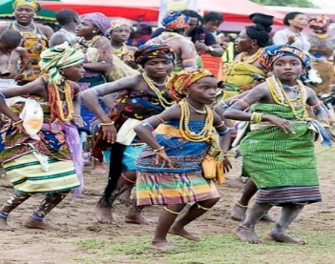  Review learners understanding in the previous lesson using questions and answers | Performing artworks include dance, music and drama.  Let learners use their senses to appreciate and appraise their own artworks.  Make decisions on agreed guidelines to appreciate and appraise an artwork. E.g. Agbadza dance  Let learners talk about the theme, gestures, makeup, costume, stage use and stage setting as they watch the video or pictures of the dance. | Review the lesson activities through questions and answers.

